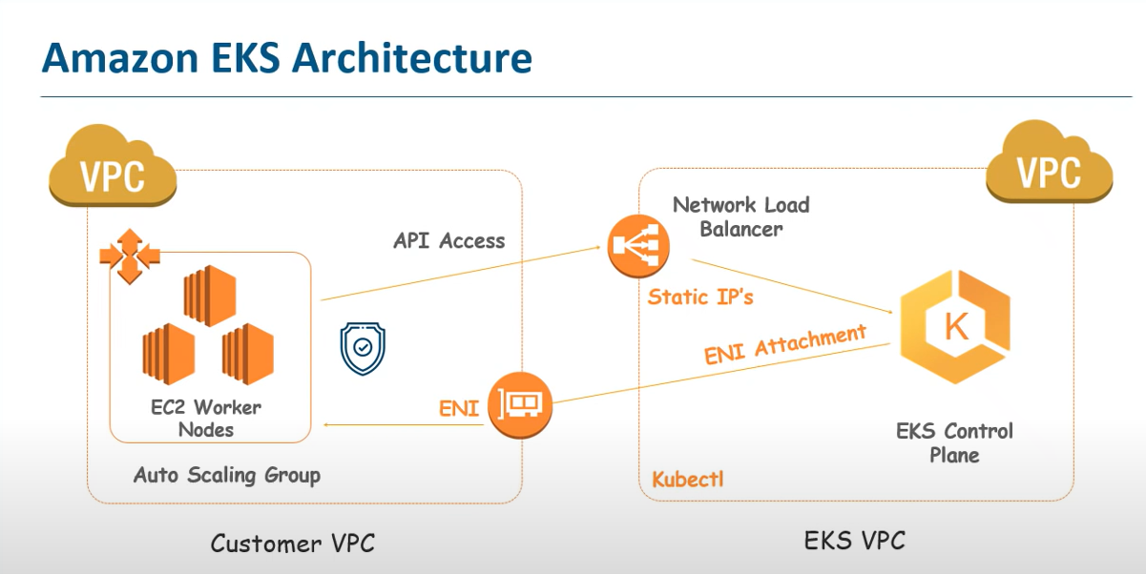

How to Create EKS in Amazon Cloud

1)configure AWS cli on machine

2)try to connect aws

Dashboard

#I am Role creation

search iam

create role for EKS service

2)VPC And security Group

cloud formation template

go to cloud formation

click on stack

https://s3.us-west-2.amazonaws.com/amazon-eks/cloudformation/2020-10-29/amazon-eks-vpc-private-subnets.yaml

go to output

copy all information

open amazon eks

create EKS

give unique name

select role

then selct VPC and security Group

click create

name- ngxcluster

select eks

server and cluster policy

eks policy

now create cloud worker nodes

using cloud formation

https://s3.us-west-2.amazonaws.com/amazon-eks/cloudformation/2020-10-29/amazon-eks-nodegroup.yaml

provided cluster name which was created

nodegroup

ami-0e609024e4dbce4a5

Open Power shell

make sure that

Kubectl and aws authonticator will be install machine

To cross check

./kubectl version --short --client

.\aws-iam-authenticator.exe help

then fire commands --nginxcluster EKS cluster name

aws eks update-kubeconfig --name nginxcluster

.\kubectl apply -f .\aws-auth-cm.yaml

.\kubectl get nodes

Now Create deployement using yaml file

.\kubectl create -f .\nginx.yaml

Now create service to monitor application

.\kubectl create -f .\nginx-svc.yaml

.\kubectl describe svc nginx

you will get load balance url to check application.

https://www.youtube.com/watch?v=6H5sXQoJiso

us-east-1

aws configure